Psych Labs: Personality Survey Project -- Data Sheet

Name of Student Participant ______________________________ Section _________

**Individual Results:** *When you get to the results page for the Personality Inventory, copy your results into this table. The maximum possible score for each factor is 1000. Make sure that you get all the values in the proper locations.*

|  |  |  |  |  |
| --- | --- | --- | --- | --- |
| Big Five Personality Factors | | | | |
| **Extraversion** | **Agreeableness** | **Conscientiousness** | **Emotional Stability** | **Openness** |
|  |  |  |  |  |

|  |  |
| --- | --- |
| **Other Variables** | |
| **Happiness** | **Gratitude** |
|  |  |

*Plot your individual results on the graph below. For each factor, put a dot on the line at the approximate position of your score, with the center circle representing a score of zero and 1000 falling on the point of the star. When you have plotted your score on each factor, use a pencil and a ruler to draw a straight line from your score on Conscientiousness to your score on Emotional Stability, then to Extraversion, then to Agreeableness, then to Openness, and finally back to Conscientiousness. Then shade in the area within your pencil lines to form your “personality profile” on the Big Five factors.*

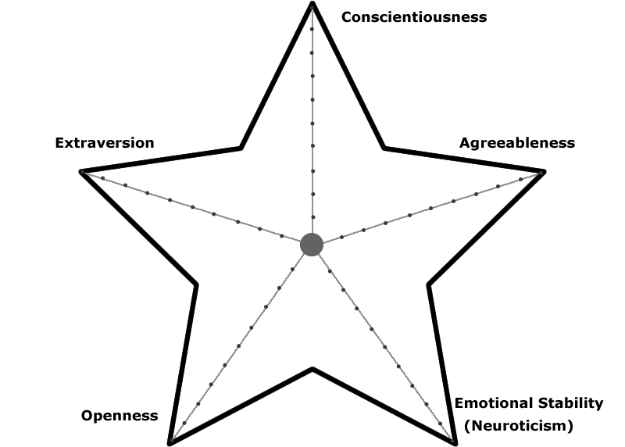

**Group Results:** *When the pooled results are available, copy those results into this table. Make sure that you get all the values in the proper locations.*

|  |  |  |  |  |
| --- | --- | --- | --- | --- |
| Big Five Personality Factors | | | | |
| **Extraversion** | **Agreeableness** | **Conscientiousness** | **Emotional Stability** | **Openness** |
|  |  |  |  |  |

|  |  |
| --- | --- |
| **Other Variables** | |
| **Happiness** | **Gratitude** |
|  |  |

*Then plot the pooled scores on the graph below. For each factor, put a dot on the line at the approximate position of the group score, with the center circle representing a score of zero and 1000 falling on the point of the star. When you have plotted the group score on each factor, use a pencil and a ruler to draw a straight line from the score on Conscientiousness to the score on Emotional Stability, then to Extraversion, then to Agreeableness, then to Openness, and finally back to Conscientiousness. Then shade in the area within your pencil lines to create an “average personality profile” for all the students who have taken this Personality Survey.*

*.*

